MACROECONOMICS
TOPICS: ECONOMIC GROWTH
THIRD WEEK: Given Date: 18th January 2024 Submission Date: 24th January 2024
Individual Activity:

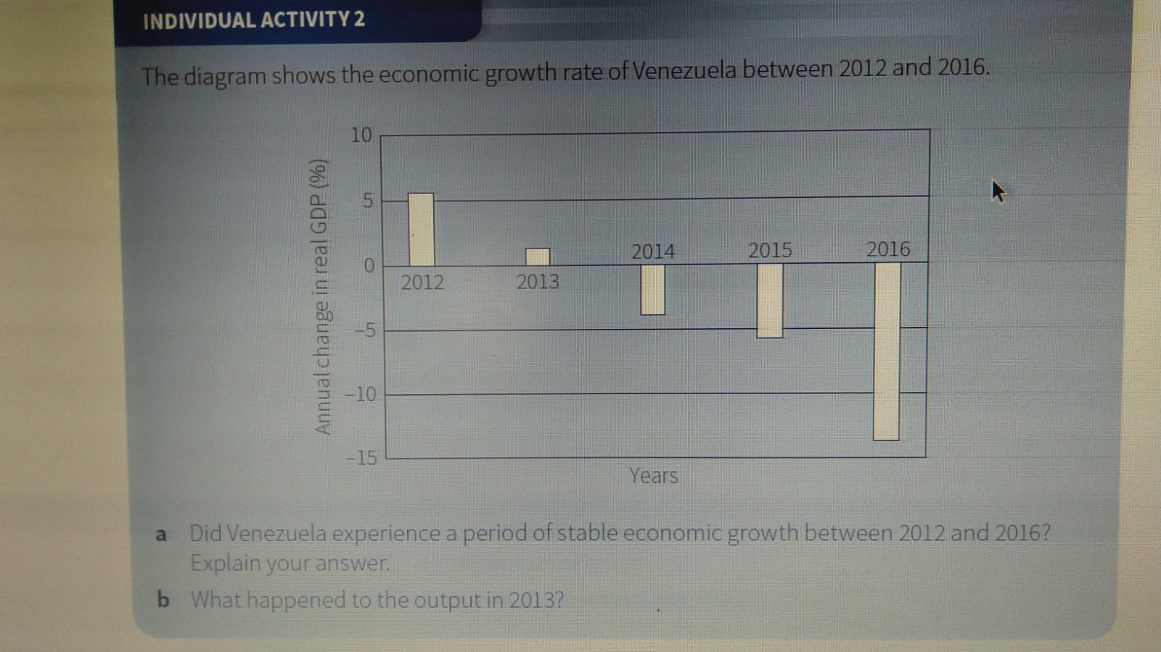
Group Activity:
- Thailand’s economic growth rate fell to 0.9% in 2014. In 2015 it rose to 2.4%, but the government was concerned that, without its intervention, it would decline again. As a result, in late 2015 the government and the Bank of Thailand both took measures to promote economic growth. The Bank of Thailand cut the rate of interest and encouraged the country’s commercial banks to lend more to households, farmers and small firms. The government increased its spending by $8.3bn. Some of its spending went on infrastructure projects, including building light railways, in a bid to extend the benefits of its stimulus Programme.
a Identify a monetary policy measure mentioned in the information.
b Why might an increase in lending cause economic growth?
c Explain why spending on infrastructure projects may promote economic growth in the long run.
Assignment Questions
- Analyse the relationship between economic growth and the budget balance.
- Discuss whether or not an increase in government spending will lead to economic growth.

